Eleanor Wratten
Eleanor.e.wratten@northumbria.ac.uk

Bio

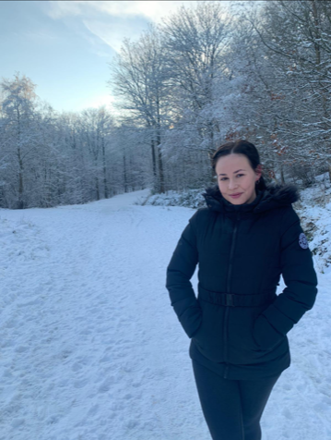
My research interests focus on the effects of climate change to ice-rich permafrost coastal responses, particularly in the context of declining landfast ice across the Northwest Canadian Arctic. Warming temperatures have increased both sea ice decline and permafrost coastal erosion in the Arctic faster than any other region globally. Concerningly, across the Northwest Canadian Arctic there has been up to ≈200% increases in coastal erosion rates.

Satellite imagery has been extensively undertaken when producing regional coastal erosion datasets because a satellite-based approach effectively produces a larger spatiotemporal record compared to modern drone surveys. However, satellite mapping can give misrepresentative retreat rates for complex landforms and do not capture true volumetric change measurements, limiting the ability to record episodic geomorphic processes including permafrost retrogressive thaw slumps, active layer detachments and block failures. Therefore, with consistently lower landfast ice extents and earlier breakup, coastal vulnerability to erosion is increased due to more days per year of direct wave to cliff contact.

Despite this concerning evidence, there are a lack of studies that specifically address any relationship between multi-scale landfast ice decline and coastal erosion but with a specific focus on process-level permafrost coastal erosion too. Therefore, we are hoping to increase the permafrost coastal erosion knowledge and also identify the impacts of climate change over the past two decades.

Research Aims

1. What are the regional and local spatiotemporal patterns of landfast ice extent decline across the Northwest Canadian Arctic from 2000-2022?
2. What are the permafrost coast responses using digitised satellite mapping across the Northwest Canadian Arctic from 2000-2022?
3. Using sites selected for distinct landfast ice patterns and permafrost coast responses across the Northwest Canadian Arctic, how does satellite mapping compare with process level detail structure from motion photogrammetric heli-surveys from 2022?

